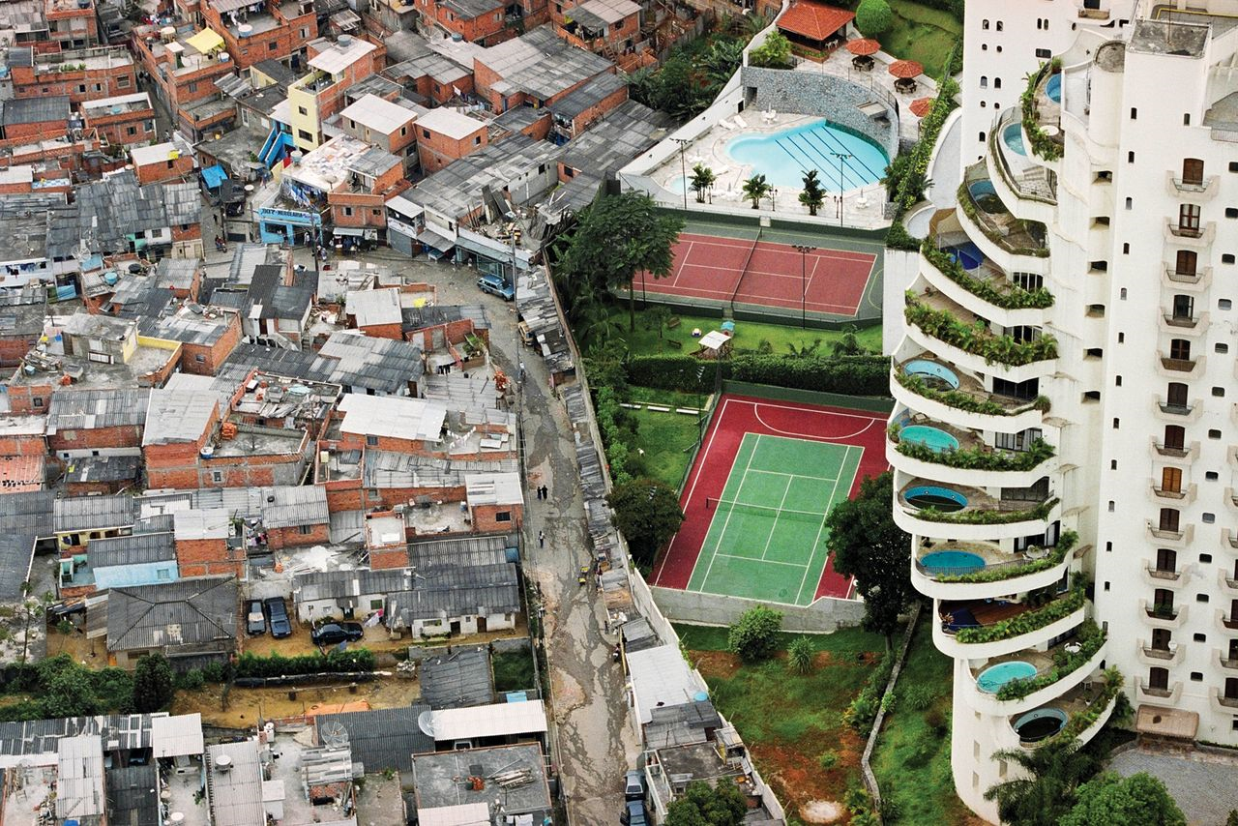
The World Since 1945
Northeastern University: HIST 2211 (Section TBD) - Spring, 2018
Date/Time TBD, Location TBD

Professor Matthew J. Bowser
Email: TBD
Office: TBD
Office Hours: TBD

I. Course Description:
This course revolves around two fundamental questions of the human condition: How did we get to where we are today, and what is our best course moving forward? The object of this study, therefore, is to answer the first question so that students may answer the second for themselves. The events that occurred following the end of the Second World War ultimately reshaped the entire world, and put its 206 states (most newly-minted during this period) on a new path. This path, following the fall of Communism in 1991, seemed to be that of increasing liberalization, free-market & free-trade capitalism, democratic nation-states, and cosmopolitan international globalism. However, since 2001, we have seen this dream of the “End of History” crumble and turn back toward protectionism, nationalism, and xenophobia. Only by understanding the complex contemporary histories of every corner of the world can we understand why our present conditions ended up the way they did and where we are headed.
The three inter-related forces of Cold War, decolonization, and globalization are key to understanding the character of this formative phase from 1945-Present, and feature largely whether we are exploring societies, cultures, politics, or economics. Through these three themes, this course provides deep historical and global context to the actors, institutions, events, and issues that have been significant in the postwar era worldwide. The course examines major issues in the postwar world such as proxy wars, nuclear proliferation, totalitarianism, migration, and ethnic violence. It also introduces important terms and theories relevant to contemporary international politics.

II. Learning Goals:
By the end of the semester, students in this class will be able to:
- Understand the importance of global historical events for the political, social, economic, and cultural state of the world today
- Understand the truly global nature of the Cold War, decolonization, and globalization by examining them region by region
- Recognize that past events are interpreted and learn how to critically evaluate different viewpoints on those events
- Evaluate the advantages and disadvantages of using contemporary/novel-style writing to immerse oneself into a culture or an historical event
- Construct a scholarly argument and defend it using evidence, both in written and oral form
- Express themselves clearly, articulately, and correctly in written and oral work
- Efficiently negotiate the demands of college-level reading and writing

NUPath: History 2211 fulfills the requirements for NUPath categories Societies and Institutions and Difference and Diversity. Specific learning goals for these categories can be found at http://www.northeastern.edu/core/requirements/.

III. Required Texts:
- Michael H. Hunt, The World Transformed: 1945 to the Present, Second Edition (Oxford: Oxford University Press, 2014/2016) pp. xxii, 601. ISBN: 978-0199371020
- Bapsi Sidhwa, Cracking India (Minneapolis: Milkweed Editions, 2006) pp. 296. ISBN: 978-1571310484
- Mark Mathabane, Kaffir Boy: The True Story of a Black Youth’s Coming of Age in Apartheid South Africa (New York: Free Press, 1968) pp. xii, 350. ISBN: 978-0684848280

All of these can be found in the university bookstore and in used copies online. Any edition or printing is acceptable for any of the books, I’ve just listed the versions I have.

Other Readings: At times, readings for this course will be posted on Blackboard. The readings will be indicated as “(Blackboard)” on the syllabus and/or will be announced in class.

IV. Grading:
All grades are based on the following scale:
94-100 A 90-93 A- 87-89 B+ 84-86 B 80-83 B- 77-79 C+
74-76 C 70-73 C- 67-69 D+ 64-66 D 60-63 D- >59 F

V. Course Requirements
- Attendance & Participation: 25%
- Book Exams: 20%
- Map Quizzes: 10%
- Midterm Paper: 20%
- Final Paper: 25%

Class Participation and Attendance (25%): Attendance is your choice, but be aware that more than three absences will automatically bring your participation grade (worth 25% of your grade) down to a 70%. Each additional absence beyond three will lower your participation grade by an additional 10 points. If you are on your cell phone in class, you will be counted absent (you may leave the room in case of emergency). If you are consistently late to class, you will be counted absent.

We will have course discussions scheduled after reading exams and movies, but lectures will also be broken up with periods of discussion. Discussions will range from full-class to smaller-group discussions to allow students multiple avenues to fulfill the participation requirement. Relevant questions during lecture will also count for participation. If you are uncomfortable speaking in group settings, please talk to me and we can arrange another way for you to fulfill your participation requirement.

Book Exams [2] (20%): Other than the Hunt textbook, we will be reading 2 novels this semester: Bapsi Sidhwa’s Cracking India (Week 4, Wednesday, February 2nd), and Mark Mathabane’s Kaffir Boy (Week 12, Friday, March 30th). Each exam will consist of 10 short answer essay questions based on your readings of the books. The questions will be factual instead of interpretative, and are meant to ensure everyone has read the books and are ready to discuss the books in more detail in the following class period.

Map Quizzes [5] (10%): There will also be FIVE map quizzes scheduled throughout the semester. All maps can be found on Blackboard. Map quizzes will be administered on the appointed Wednesdays at the start of class. Students will be expected to identify all countries in Africa, Latin America, Asia, the Middle East, and Europe. Here is a short list of the topics and dates of the map quizzes:
- Europe: Week 3, Wednesday, January 24
- Asia: Week 5, Wednesday, February 7
- Middle East: Week 8, Wednesday, February 28
- Latin America: Week 11, Wednesday, March 21
- Africa: Week 12, Wednesday, March 28

Midterm Paper (20%): There is no midterm exam for this course. Instead you will each write a midterm paper. The midterm paper for this course will be a short case study of decolonization (4-5 pages double-spaced). You will pick any formerly colonized nation of your choice and answer the following questions: Was decolonization an improvement or a detriment to the country? In what ways was it positive and in what ways was it negative? What are some of the most important colonial legacies that remain embedded in the postcolonial government, society, and/or culture? The paper can pull from the Hunt textbook but with at least 2 other peer-reviewed sources (preferably from a historian). We will discuss the paper structure in detail during Week 6. Midterm papers will be due via email on Friday, March 2 by 11:59pm. I will not grant an extension 48 hours before the essay is due unless there is a medical or family emergency.

Final Paper (25%): There is no final exam for this course. Instead you will each write a final paper. The final paper for this course will be a current event analysis (8-10 pages double-spaced) that explores and presents a concise historical context/background to a contemporary issue in the newspaper or other media. The paper will involve choosing a current event, researching historical context/background using the Hunt textbook and at least 3 other peer-reviewed sources (preferably from a historian), and using at least 1-2 primary sources to supplement your analysis. We will discuss the paper structure in detail during Week 13. Final papers will be due via email on Sunday, April 22 by 11:59pm. I will not grant an extension 48 hours before the essay is due unless there is a medical or family emergency.

VI. Reasonable Accommodation:
Students with documented learning disabilities will receive reasonable accommodation in this class. If you have a learning disability, please see me so that we can work out the details. To contact and register with Northeastern’s Disability Resource Center, go to 20 Dodge Hall or www.drc.neu.edu, or call 617-373-4428.

VII. Academic and Personal Integrity:
No cheating. No copying other people’s work. No plagiarism. No lying about late assignments: For all written and oral assignments, you are expected to properly cite the source of ideas or information you use that are not your own. This includes material used from printed sources and from web sites. Failure to do so may be considered plagiarism and may result in the matter being referred to the department for resolution. If you use the words of another person, those words must be enclosed in quotation marks and a proper reference to the source must be made. Failure to do this is plagiarism. Whenever you are using some else’s ideas (but not their precise words), you should indicate this through a footnote or reference of some kind. Again, failure to do this is plagiarism.

Please abide by the standards of academic integrity of our community:
“Northeastern University is committed to the principles of intellectual honesty and integrity. All members of the Northeastern University community are expected to maintain complete honesty in all academic work, presenting only that which is their own in tests and assignments. If you have any questions regarding proper attribution of the work of others, contact your professor prior to submitting the work for evaluation.” http://www.northeastern.edu/osccr/academicintegrity/index.html

Title IX: Northeastern’s Title IX Policy prohibits Prohibited Offenses, which are defined as sexual harassment, sexual assault, relationship or domestic violence, and stalking. The Title IX Policy applies to the entire community, including male, female, transgender students, and faculty and staff.

If you or someone you know has been harassed or assaulted, confidential support and guidance can be found through:
- University Health and Counseling Services staff (http://www.northeastern.edu/uhcs/)
- Center for Spiritual Dialogue and Service clergy members (http://www.northeastern.edu/spirituallife/).

By law, those employees are not required to report allegations of sex or gender-based discrimination to the University.

Alleged violations can be reported non-confidentially to the Title IX Coordinator within The Office for Gender Equity and Compliance at: titleix@northeastern.edu and/or through NUPD (Emergency 617.373.3333; Non-Emergency 617.373.2121). Reporting Prohibited Offenses to NUPD does NOT commit the victim/affected party to future legal action.

VIII. Late Work Policy:
All assignments are due in class as noted in the Course Schedule. Except for emergencies, for every day that your assignment is late, one half-letter grade will be deducted (i.e., a B paper will receive a B- on the first day late, and a C+ on the second day late).

As for the Map Quizzes and Book Exams, you are expected to attend class on the days we have them. If you cannot make it for any reason, try to let me know beforehand via email. If you need to miss a Map Quiz or Book Exam, it is your responsibility to schedule a make-up exam. If you haven’t contacted me within one week of the quiz or exam date to schedule a make-up, you will receive no credit for the assignment.

Finally, make-up exams for Book Exams will be a different format from the in-class exam. In-class exams are 10 short answer responses, make-up exams will be 1-2 questions requiring longer, more-in-depth responses.

IX. Communication:
I welcome students to contact me by email, after class, or during office hours. If you cannot make my office hours, please email me and we can set up an appointment. Please check Blackboard and your syllabus first before contacting me about scheduling issues or reading assignments, since much of that information is available to you. I make every effort to respond promptly to questions, but please allow 24-48 hours for an email response. Do not send essay drafts for review the day before they are due.

X. Course Schedule:

Week 1: The World in 1945

Wednesday, January 10:
Discussion: Introductions/Syllabus
Lecture: World History Up to 1756

Friday, January 12:
Reading: Hunt, “Introduction” (1-27); “Hopes and Fears Contend” (29-33); Chapter 1 Introduction and “Origins of the Rivalry” (35-50).
Lecture: World History from 1756 to 1939

Week 2: The Cold War
** Start Reading Bapsi Sidhwa, Cracking India **

Wednesday, January 17:
Movie: (in class) Doctor Strangelove (1964) 1hr 35mins
** Receive Europe Map handout (Blackboard), Quiz Wednesday, January 24 **

Friday, January 19:
Reading: Eric Schlosser, “Almost Everything in ‘Dr. Strangelove’ was True,” New Yorker, 2014 (Blackboard, PDF, 7 pages); Hunt, “The Conflict Goes Global” (51-75).
Discussion: Doctor Strangelove (1964)/Schlosser (2014)
Lecture: World War II and the Cold War

Week 3: Europe in Global Context

Wednesday, January 24:
Reading: Hunt, Chapter 2: “The International Economy” (77-109).
Map Quiz: Europe (10-15mins)
Lecture: Europe: Cold War and Reconstruction

Friday, January 26:
Lecture: Europe: Decolonization and Globalization

Week 4: South Asia in Global Context
** Finish Reading Bapsi Sidhwa, Cracking India **

Wednesday, January 31:
Reading: Hunt, Chapter 3: “The Third World” (111-143).
Lecture: Decolonization in India and Pakistan
** Receive Asia Map handout (Blackboard), Quiz Wednesday, February 7 **

Friday, February 2:
Book Exam: Sidhwa, Cracking India (50 mins)
Discussion: Sidhwa, Cracking India
Lecture: The Cold War and Globalization in India and Pakistan

Week 5: East Asia in Global Context

Wednesday, February 7:
Reading: Hunt, Chapter 6 Introduction and “The Maoist Experiment in China” (235-243); “The Rise of An East Asian Bloc” (348-362); “The Return of Asia” (506-515).
Map Quiz: Asia (10-15mins)
Lecture: Decolonization in East Asia

Friday, February 9:
Lecture: The Cold War and Globalization in East Asia

Week 6: Southeast Asia in Global Context

Wednesday, February 14:
Reading: George Orwell, “Shooting an Elephant,” New Writing, 1936 (Blackboard, PDF, 6 pages)
Discussion: Orwell (1936)
Lecture: Myanmar in Global Context

Friday, February 16:
Reading: Vincent Bevins, “What the United States Did in Indonesia,” The Atlantic, 2017 (Blackboard, PDF, 5 pages)
Discussion: Bevins (2017)
Lecture: Indonesia in Global Context
Oral History and Discussion: (in class) “Living Through Dictatorship and Resistance with Kemal Taruc” (Podcast)
Workshop: Midterm Paper, Sources, and Format (10-15 min)

Week 7: The United States and Proxy Wars

Wednesday, February 21:
Reading: Hunt, Chapter 4 Introduction and “The Beginnings of Coexistence” (151-164); “To the Nuclear Brink over Cuba” (164-168); “The Vietnam Quagmire” (168-174); “The Quake of ‘68” (174-187); “Vietnam’s Fight for the South” (243-249).
Lecture: The United States and the World in the 1950s
** Receive Middle East Map handout (Blackboard), Quiz Wednesday, February 28 **

Friday, February 23:
Reading: Hunt, “Abundance and Discontent in the Developed World” (189-233).
Lecture: The Global 1960s

Week 8: West Asia in Global Context (Part 1)

Wednesday, February 28:
Reading: Hunt, “Remaking the Middle East and North Africa” (276-291); “Religious Challenge in Iran” (379-383); “Revolutionary Aftershocks in the Middle East” (383-385).
Map Quiz: Middle East (10-15mins)
Lecture: The Middle East (Part 1)

Friday, March 2:
Reading: Stephen Kinzer, “Inside Iran’s Fury” Smithsonian Magazine, 2008 (Blackboard, PDF, 12 pages).
Discussion: Kinzer (2008)
Lecture: The Middle East (Part 2)

Midterm Papers: Due Friday, March 2 by 11:59pm (EST) via Email

Week 9: Spring Break

Wednesday, March 7: NO CLASS

Friday, March 9: NO CLASS

Week 10: West Asia in Global Context (Part 2)
** Start Reading Mark Mathabane, Kaffir Boy **

Wednesday, March 14:
Reading: Hunt, “Conflict over Palestine” (393-401); Crosscurrents and Conflicts in the Middle East” (491-506).
Lecture: Israel and Palestine in Global Context
** Receive Latin America Map handout (Blackboard), Quiz Wednesday, March 21 **

Friday, March 16:
Movie: (in class) Waltz with Bashir (2008) 1hr 30mins

Week 11: Latin America in Global Context
Wednesday, March 21:
Reading: Hunt, “The Caribbean Basin” (249-263); “Repression and Resistance in Guatemala” (401-406); “Latin America beyond the Cold War” (485-491).
Map Quiz: Latin America (10-15mins)
Discussion: Waltz with Bashir (2008)
Lecture: U.S. Policy in Latin America: Guatemala, Argentina, Chile
** Receive Africa Map handout (Blackboard), Quiz Wednesday, March 28 **

Friday, March 23:
Reading: Mark Ensalaco, Chapter 1: “The Victors and the Vanquished” from Chile Under Pinochet: Recovering the Truth, 2000 (Blackboard, PDF, 21 pages)
Movie: (in class) Colonia (2015) 1hr 46mins

Week 12: Africa in Global Context
** Finish Reading Mark Mathabane, Kaffir Boy **

Wednesday, March 28:
Reading: Hunt, “Decolonization in Sub-Saharan Africa” (263-276); “South African Apartheid under Siege” (386-393); Part Three Introduction (293-298); Chapter 7, “The Cold War Comes to a Close” (299-331).
Map Quiz: Africa (10-15mins)
Discussion: Colonia (2015)/Ensalaco (2000)
Lecture: South Africa in Global Context

Friday, March 30:
Book Exam: Mathabane, Kaffir Boy (50mins)
Lecture: Kenya in Global Context (Guest Lecture by Jamie Parker, Northeastern University)

Week 13: Neoliberalism and Globalization

Wednesday, April 4:
Reading: Hunt, “The United States in Transition” (335-348); “Revived Bloc Building in Europe” (362-371); “Dreams of Development in Disarray” (406-417); Chapter 10: “The Power and Perils of Globalization (419-473).
Discussion: Mathabane, Kaffir Boy
Lecture: Neoliberalism, Globalization, and the End of the Cold War
Workshop: Final Paper, Sources, and Format (10-15 min)

Friday, April 6:
Reading: Hunt, “The New World’s New Era” (476-485); “The Old World’s Old Problems”
(515-530).
Lecture: The World Since 2001

Week 14: World Historical Approaches & Wrap-up

Wednesday, April 11:
Reading: Excerpt from Julian Go, Patterns of Empire: The British and American Empires,
1688 to the Present, 2011 (Blackboard, PDF); Excerpt from Ian Morris, Why the West Rules – For Now: The Patterns of History, and What They Reveal about the Future, 2010 (Blackboard, PDF).
Lecture: The Present and the Future
Discussion: Go (2011)/Morris (2010)/The Future

Friday, April 13:
Workshop: Final Papers. Bring your computers, questions, and sources. You can bring drafts or outlines and discuss them with me or fellow students. Also, you can just use the time to start/continue writing!

Week 15: Paper Writing

Wednesday, April 18: NO CLASS: Prepare your final papers!

Final Papers: Due Sunday, April 22 by 11:59pm (EST) via Email

