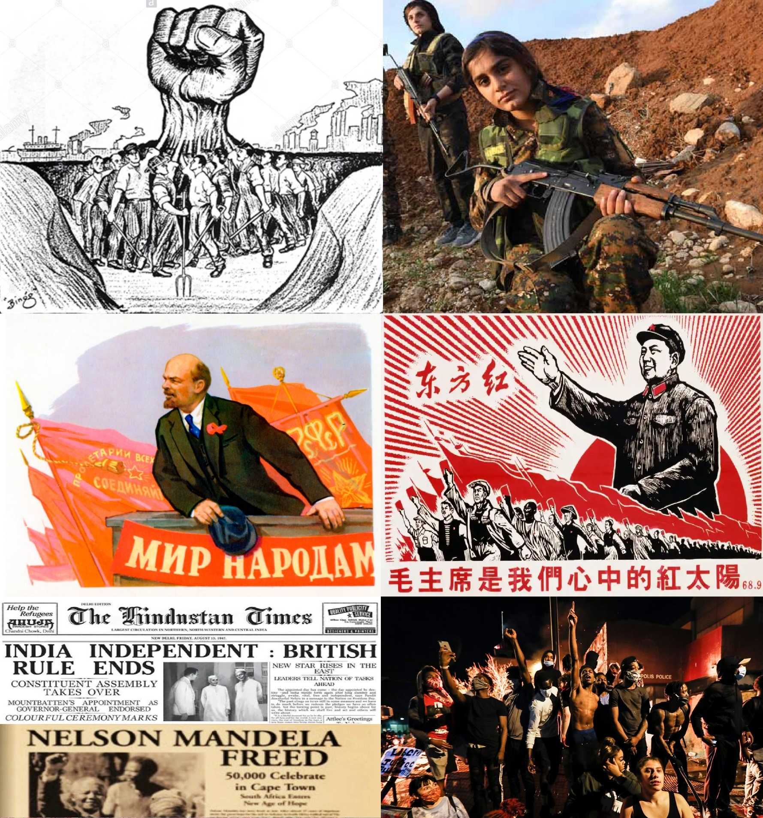
HIST 2301/2: Modern Insurrection
Fall 2021
Professor Matthew Bowser

Syllabus
HIST 2301: Civil Wars, Insurgencies, and Violent Non-State Actors in Modern World History (CRN# 10509)
HIST 2302: Historical Writing Seminar (CRN# 10428)
Semester: Fall 2021
Class Meetings: MW 2:50 - 4:30 PM ET, Forsyth 242

Instructor Information
Instructor: Dr. Matthew Bowser (Prof. Bowser)
Office: Holmes Hall 281
Office Hours: MW 1:30-2:30 PM ET (physical or Zoom), or by appointment (Zoom), Link: https://northeastern.zoom.us/j/2577754231
Email: m.bowser@northeastern.edu

I. Course Description:
The purpose of studying history is to understand the world that we currently inhabit by studying how it came to be that way. History provides context for present society just as, for example, studying evolution provides context for human bodily function. But unlike natural phenomena, the present conditions for human society were shaped by human beings, who chose, justified, and most importantly, contested the path of human history. The rationalized and centralized states of the early modern world resulted from contestation of feudal social organization; the liberal capitalist democracies of the modern world resulted from contestation of aristocratic privilege and the Divine Right of Kings. Understanding contestations, therefore, is key to understanding how historical change occurs. The liberal capitalist world-system that we live within today also has its injustices and its contestations. In this seminar, we will learn to think, research, and write like historians by studying modern insurrectionary theory and praxis. We will address the major schools that have defined counter-hegemonic movements since the dawn of the capitalist world-system in the early nineteenth century: Marxism, Anarchism, Anti-Colonialism, Anti-Racism, Anti-Fascism, Feminism, Indigenous and Queer Insurrectionism, and more. All of these schools have one key commonality: all cultivate alternatives and imagine what a modern society would look like without Western-dominated global capitalism, for better or worse.
This theme will provide a framework around which you will all become “journeymen” in the “guild” of history: you will learn how to identify historical sources (primary and secondary), how to analyze complex historical issues, and how to be a historian by planning, researching, managing, and writing your own original, historical research paper on a topic of your choosing related to the theme.

II. Learning Goals:
By the end of the semester, students in this class will be able to:
- Understand the importance of global historical events for the political, social, economic, and cultural state of the world today
- React to news and world affairs, and approach present-day politics and political activism, with an educated, fully-contextualized historical understanding of the issues underlying each situation
- Critically analyze and identify the principal arguments of both primary and secondary historical media
- Evaluate sources for bias, origin, scholarly rigor, and usefulness
- Construct a historical research question and a historical hypothesis/argument
- Perform independent research, utilizing a wide variety of print and digital resources
- Properly cite historical works, prepare a literature review, and construct a bibliography
- Produce a major historical research paper
- Express themselves clearly, articulately, and correctly in written and oral work

III. Required Texts:

There are no required texts for this course. All readings and materials will be posted directly in the “Modules” tab of our course Canvas site. These readings will be noted in our Course Schedule below.

IV. Grading:
All grades are based on the following scale:
94-100 A 90-93 A- 87-89 B+ 84-86 B 80-83 B- 77-79 C+
74-76 C 70-73 C- 67-69 D+ 64-66 D 60-63 D- >59 F

V. Course Requirements:
- Attendance & Participation: 20%
- Discussion Posts: 20%
- Discussion Leadership: 10%
- Research Paper: 50%

Attendance & Participation (20%): Attendance is mandatory, either in-person or virtually. Half of this grade will account for attendance. Each student will be allowed THREE absences WITHOUT an excuse. Please use these three absences for sickness, doctor’s appointments, mental-health days, social life, etc.; they are yours to use and there’s no need to send me an e-mail to let me know. In exchange for these three free days, there will be no further excused absences (except under extreme circumstances) so use them wisely. Each additional absence beyond three will lower this half of the grade by 10%. The other half of this grade is for class discussion. This course will be almost entirely based around discussion. will have a formal discussion in which students will analyze and come to your own conclusions on the Canvas readings. This participation half of the grade will be determined by your level of engagement with the course materials (for example, if you speak a lot but it's not substantive, you will probably get a “B”; if you speak well and substantively, you will get an "A"; if you don’t speak much or are shy in public settings, make sure your discussion posts are spectacular and demonstrate a critical engagement with the readings and you will still get an “A”; total or partial disengagement is what will merit a "C" or below).

Discussion Posts (20%): Each week, students will complete a discussion board post (for a total of 10 posts). For each post, students will respond to discussion prompts in no less than two paragraphs (roughly 300-400 words), briefly summarizing what each assigned work covers, explaining how the works are connected, and providing their own critical interpretation. In addition, students must respond to at least two other student’s responses in a substantive way, which will help to facilitate in-class discussions. These posts will be due on Sunday nights at 11:59 PM ET (in preparation for class on Monday).

Discussion Leadership (10%): During Week 1, students will be grouped into five small groups of three or more members each. In Week 2, each group will be assigned to lead discussion in class for two weeks of their choice throughout the semester, and will be responsible for coming up with discussion questions for the Canvas readings assigned for their week. Before their selected week, students will meet with each other on Zoom, chat/email, or by some other method to prepare to lead discussion. Each discussion will take place on both Monday and Wednesday of the assigned week (minus workshop time on Monday), so each student should prepare at least 3-4 questions to make sure that discussion carries through both class periods. Division of the responsibility of leading discussion can be decided by members of each group (for example, they can choose to have one “speaker” while others think of questions, or they can take turns asking questions). If discussion leaders are prepared to lead discussion on their appointed weeks, all group members will receive full credit (100%).

Research Paper (50%): The true purpose of this seminar is for students to become historians and to write an original, historical research paper. This paper will have several scaffolding assignments throughout the semester to ensure that students are keeping up with the work necessary to produce such a document:
- Proposal (5%): In this first assignment, due in Week 8 on Friday, October 29th, students will submit a topic proposal for their final paper, which will include one paragraph explaining what topic they have chosen and what (tentatively) they will argue about it and an annotated bibliography of at least 3 secondary sources and at least 1 primary source. Students may select any topic for their final paper which falls under the broad category of revolutions, civil wars, insurgencies, or violent non-state actors in the 19th or 20th centuries.
- Draft Research Paper (10%): In this second assignment, due in Week 11 on Friday, November 19th, students will submit a 5-page draft of their research paper with the remainder of the paper outlined (and the outline should highlight any problematic areas where students are struggling with their argument or need more sources/information). This draft will NOT include an introduction, so part of the exercise should be to make clear what the argument/subject is simply through clear writing on the subject. At the end, students will include a short bibliography of 6 secondary sources and 2 primary sources. Students will both upload their draft to the assignment page on Canvas and send their draft to their fellow group members for peer review.
- Peer Review (5%): In this third assignment, due in Week 13 on Friday, December 3rd, students will review the draft papers of their group members and write a short response (about 1 paragraph each) that provides constructive criticism: highlights strengths, points out where the draft needs work or more specificity, makes suggestions for problematic areas, etc. Students will submit peer reviews to their group members as well as to the assignment page on Canvas.
- Presentation (5%): In this fourth assignment, due in Week 14 on Monday, December 6th, students will be assigned a time during class to present their final research paper with a brief spoken presentation (no Powerpoint). The purpose of this assignment is to practice BRIEFLY and SUCCINTLY summarizing one’s argument and presenting its major interventions into the existing literature. Therefore, students will only have 5 minutes each to make their presentation, which I will time and cut off at the five-minute mark. Students will prepare questions for their peers, which will be discussed in Wednesday’s class (along with lingering questions about the final paper).
- Final Research Paper (25%): The final research paper must be uploaded to the assignment page by Wednesday, December 15th at 11:59 PM ET. The final paper must be at least 15-20 double-spaced pages (~5,500 to 7,000 words); have a clear introduction and conclusion that sets up and wraps up a strong historical argument, respectively; and include at least 7-10 secondary sources and 3 primary sources. More details in the final paper assignment page on Canvas.

IV. Academic Integrity:
Your instructor and Northeastern University are intolerant of any form of academic dishonesty. Cheating or plagiarism of any kind will result in an automatic F for the course. Students who cheat will immediately be referred to the Office of Student Conduct and Conflict Resolution, and will receive the maximum university discipline possible. To ensure you understand Northeastern’s policy on Academic Integrity, visit http://www.northeastern.edu/osccr/academicintegrity/index.html

V. Accommodations & Support:
Reasonable Accommodation: Students with documented learning disabilities will receive reasonable accommodation in this class, in accordance with Northeastern University policy (https://www.northeastern.edu/policies/pdfs/Policy_on_Reasonable_Accommodation.pdf). If you have a learning disability, please let me know so that we can work out the details. To contact and register with Northeastern’s Disability Resource Center, go to 20 Dodge Hall or http://www.northeastern.edu/drc/, or call 617.373.4428.

Title IX: Northeastern’s Title IX Policy prohibits discrimination based on gender, which includes sexual harassment, sexual assault, relationship or domestic violence, and stalking (for more information, see the website for the Office for University Equity and Compliance at https://www.northeastern.edu/ouec/) . The Title IX Policy applies to the entire community, including male, female, transgender students, and faculty and staff. If you or someone you know has been harassed or assaulted, confidential support and guidance can be found through University Health and Counseling Services staff (http://www.northeastern.edu/uhcs/) and the Center for Spiritual Dialogue and Service clergy members (http://www.northeastern.edu/spirituallife/). By law, those employees are not required to report allegations of sex or gender-based discrimination to the University. Alleged violations can be reported non-confidentially to the Title IX Coordinator within The Office for Gender Equity and Compliance at: titleix@northeastern.edu and/or through NUPD (Emergency 617.373.3333; Non-Emergency 617.373.2121). Reporting Prohibited Offenses to NUPD does NOT commit the victim/affected party to future legal action.

WeCare: WeCare offers supports for students during times of difficulty or challenge. You can find WeCare at 226 Curry Student center Monday - Friday from 8:30-5:00, call at 617-373-7591, or email wecare@northeastern.edu

Mental Health Resources: In addition to mental health resources available through Northeastern University Health and Counseling Services, Northeastern has added Find@Northeastern, which is a 24/7 mental health consulting line and can be reached at 1-877-223-9477.

Peer Tutoring: The Peer Tutoring Program offers a wide range of tutoring services to meet the academic needs of undergraduate students. If you need academic assistance, contact the Peer Tutoring Program Monday through Friday from 9:00am to 5:30pm. Peer tutoring services are free and open to all NU undergraduate students. Peer tutoring begins the second week of classes and ends the last day of classes. The Peer Tutoring Program is located in 1 Meserve Hall. Call 617- 373-8931, email peertutoring@northeastern.edu, or visit the weblink above.

International Tutoring Center: The International Tutoring Center (ITC) provides current Northeastern University international students with free, comprehensive English language and academic support. The ITC includes English as a Second Language Tutoring (ESL), Language and Culture Workshops, and Reading Workshops. For more information on available workshops and tutoring opportunities please visit the ITC weblink above.

Snell Library: Snell Library offers a variety of resources for undergraduate research, including subject-specific Research Guides, help with citation and bibliography, and 24/7 chat support . The library also houses the Digital Media Commons, which offers a variety of resources for instructors and students for multimedia projects.

COVID-19 Policy: As you're aware, due to the COVID-19 pandemic the academic experience will be different for all of us. When physically in person for this course, you'll be responsible for wearing a mask that covers your mouth and nose, practicing physical distancing of 6 feet with other individuals, and keeping your desk and chair on the designated spots on the ground. You will also be responsible for wiping down your own desk, chair, and other frequently touched surfaces with alcohol wipes or other approved disinfectant upon arrival and departure from the classroom (or lab, studio, etc.). It is imperative that we work together as a community to uphold these standards to help mitigate the risk of spreading the virus. Failure to do so may result in a referral to the Dean of Student Affairs Office. For more information about expectations for the Fall, please review the information in the links below:
- Reopening Northeastern
- COVID-19 Updates from the University
- COVID-19 Resources for all Northeastern Students

Inclusion and Diversity: I value all students regardless of their background, country of origin, race, religion, gender, sexual orientation, ethnicity, or disability status, and am committed to providing a climate of excellence and inclusiveness within all aspects of the course. If you have any concerns in this area or are facing any special issues or challenges, I encourage you to discuss the matter with me as you feel comfortable, with assurance of full confidentiality (the only exceptions being mandatory reporting of NU Academic Integrity Policy violations and Title IX sex and gender discrimination).

VI. Late Work Policy:
All assignments are due in class as noted in the Course Schedule. Except for emergencies, for everyday that your assignment is late, one half-letter grade will be deducted (i.e., a “B” assignment will receive a “B-” on the first day late, a “C+” on the second day late, etc.).

VII. Communication:
I encourage students to contact me or your TAs by email, after class, or during office hours. If you cannot make office hours, please email one of us and we can set up an appointment. Please check Canvas and your syllabus first before contacting us about scheduling issues or reading assignments, since much of that information is available to you. We will make every effort to respond promptly to questions, but please allow roughly 24 hours for an email response. Do not send essay drafts for review the day before they are due.

VIII. Course Schedule:

WEEK ONE: Introductions
Readings: None
Assignments: Student Info Sheet due Thursday, September 9th at 11:59 PM ET

Wednesday, September 8
Discussion: Syllabus/Introductions

WEEK TWO: The Modern World-System
Readings: Storey
Assignments: None

Monday, September 13
Lecture: The Establishment of the Modern World-System
Lecture: The Globalization of the Modern World-System

Wednesday, September 15
Lecture: The Ideology of the Modern World-System
Discussion: Group Leadership Week Selections
Discussion: Storey

WEEK THREE: Socialism and Labor Movements in the Nineteenth Century
Readings: Engels/Gaskell/Avery/Charlton
Assignments: Discussion Post 1 due Sunday, September 19th at 11:59 PM ET

Monday, September 20
Workshop 1: Coming Up with a Research Question
Discussion: Socialism and Labor Movements

Wednesday, September 22
Discussion: Socialism and Labor Movements

WEEK FOUR: Communism
Readings: Lenin/Mao/Brown/Allen
Assignments: Discussion Post 2 due Sunday, September 26th at 11:59 PM ET

Monday, September 27
Workshop 2: How to Find and Read Academic Secondary Sources
Discussion: Communism

Wednesday, September 29
Discussion: Communism

WEEK FIVE: Anarchism
Readings: Goldman/Kropotkin/Woods/Orwell
Assignments: Discussion Post 3 due Sunday, October 3rd at 11:59 PM ET

Monday, October 4
Workshop 3: How to Cite Sources and Write a Bibliography
Discussion: Anarchism

Wednesday, October 6
Discussion: Anarchism

WEEK SIX: Nationalism and Fascism
Readings: Carnegie/Rattansi/Paxton
Assignments: Discussion Post 4 due Sunday, October 10th at 11:59 PM ET

Monday, October 11
NO CLASS, Indigenous Peoples’ Day

Wednesday, October 13
Discussion: Nationalism and Fascism

WEEK SEVEN: Anti-Colonialism and Anti-Racism
Readings: Fanon/Cesaire/Ho Chi Minh/Shabazz/Baldwin
Assignments: Discussion Post 5 due Sunday, October 17th at 11:59 PM ET

Monday, October 18
Workshop 4: How to Write a Proposal, Craft a Historical Argument, and Do an Annotated Bibliography
Discussion: Anti-Colonialism and Anti-Racism

Wednesday, October 20
Discussion: Anti-Colonialism and Anti-Racism

WEEK EIGHT: Feminist and Queer Insurrection
Readings: Beauvoir/Fawcett/Various Second Wave Feminism Sources/Walsh/Nardini Gang
Assignments: Discussion Post 6 due Sunday, October 24th at 11:59 PM ET/Proposal due Friday, October 29th at 11:59 PM ET

Monday, October 25
Workshop 5: How to Design a Research Paper
Discussion: Feminist and Queer Insurrection

Wednesday, October 27
Discussion: Feminist and Queer Insurrection

WEEK NINE: Case Study 1, The Naxalite Insurgency
Readings: Chandra/HRW/Strobl
Assignments: Discussion Post 7 due Sunday, October 31st at 11:59 PM ET

Monday, November 1
Workshop 6: How to Do a Peer Review
Discussion: The Naxalite Insurgency

Wednesday, November 3
Discussion: The Naxalite Insurgency

WEEK TEN: Case Study 2, Chavismo Populism in Venezuela
Readings: Cannon/Aleem/Bartley & O’Briain
Assignments: Discussion Post 8 due Sunday, November 7th at 11:59 PM ET

Monday, November 8
Workshop 7: How to Present Your Research
Discussion: Venezuela

Wednesday, November 10
Discussion: Venezuela

WEEK ELEVEN: Case Study 3, The Zapatista Autonomous Zones
Readings: Stephen/Klein/Eichert
Assignments: Discussion Post 9 due Sunday, November 14th at 11:59 PM ET/Draft Research Paper due on Canvas and to Group Members by Friday, November 19th at 11:59 PM ET

Monday, November 15
Discussion: The Zapatista Autonomous Zones

Wednesday, November 17
Discussion: The Zapatista Autonomous Zones

WEEK TWELVE: Thanksgiving Break
NO CLASS, Enjoy the Break!

WEEK THIRTEEN: Contemporary Insurrections
Readings: Taylor/Todrys/The Invisible Committee
Assignments: Discussion Post 10 due Sunday, November 28th at 11:59 PM ET/Peer Review due on Canvas and to Group Members by Friday, December 3rd at 11:59 PM ET

Monday, November 29
Discussion: Contemporary Insurrections

Wednesday, December 1
Presentations

WEEK FOURTEEN: Presentations
Readings: None
Assignments: Presentation due in class on Monday, December 6th/TRACE Evaluation!

Monday, December 6
Presentations

Wednesday, December 8
Discussion: Discussion on Presentations and Final Papers

FINALS WEEK: Final Research Paper Submission
Final Research Paper due Wednesday, December 15th at 11:59 PM ET

